ABOUT 20/20

Education 20/20 Inc. is an independent, broad based, national, not-for-profit education organization, located in Charlottetown, PEI and is governed by a volunteer Board of Directors.

Vision: A quality education for every Canadian.

Directors: Directors: Don Glendenning, President, Bill Whelan, Vice President, Tom White-Hassler, Katherine McQuaid, Donald DesRoches. Amber Jadis, Tess Miller, Ronnie McIntosh and Ross Reid

Our thanks
- Donors, volunteers and friends
- Don Glendenning, Editor
- Louise Carota, artist
- ??

Information including donations: www.education2020.ca

Sponsors:

Pub1/2018


Learner on the Road of Life by Louise Carota

ABOUT EDUCATION

Education 20/20 Inc.
101 Kent St., PO Box 624/rue Kent, BP 624
Charlottetown, PEI C1A 1M0 Canada
www.education2020.ca – pei@education2020.ca
1

THIS BOOKLET

Our future depends to a large degree on the nature and quality of our education; it behooves us, therefore, to make sure that education is a quality one. This booklet provides a framework, not a blueprint, for decision-making in the educational component of our lives.

Organizing and delivering education services is a complex matter given the variables - geography, culture, individual differences, ages, prior learning and personal interests. To this we must add the evolving world in which we find ourselves including a global reach, instant communication and artificial intelligence.

Canada has a long and enviable history of public education but public education is out of sync with the times. The milieu in which education operates is dramatically different from its roots as are the tools available to those who make it happen. A review and clarification of the framework is crucial. The release of this booklet is simply a step in the process.

The decision to release this in draft form is deliberate for two reasons, (1) because the shape of tomorrow’s model is still emerging and (2) you, the learner, will play the significant role in giving it form.

WATCH FOR EDITION 2

LEARNING PATH
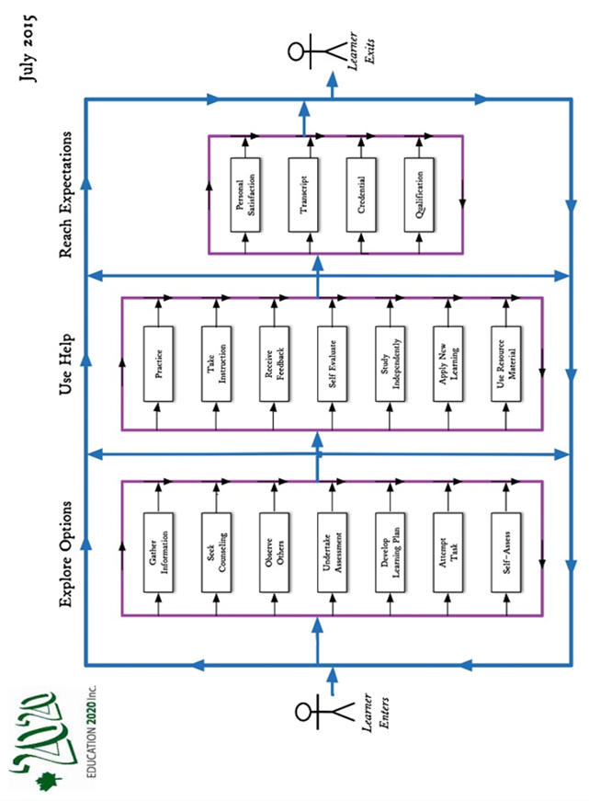

ROAD OF LIFE

We are all on the road of life. The road of life is a metaphor for the experiences we encounter between birth and death. While on the road, each person fills a number of roles, that of an
• individual,
• family member,
• citizen,
• student
• producer and
• consumer

HURDLES
The road of life, like any road, presents its share of hills, hollows twists and rough spots including:
• Need for formal qualifications
• Limits to our own learning
• Culture we carry with us and the culture we acquire
• Personal commitments and responsibilities

ESSENTIAL SKILLS
Some skills are considered essential for everyday living; while readers could make their own list, most lists would likely include the following:
• Communications
• Numeracy
• Community awareness
• Self-management
• Interpersonal relationships
• Information technology

TYPICAL EDUCATION SERVICES
Education system - services put in place by a community to encourage and support the education of its citizens These are considered typical functions or services of an education system

Information and Counselling
- Recent and independent information needed by Islanders in the making of decisions about their own education or the education of others
Governance and Leadership
- In the form of a body and organization with vision and responsibility to put in place and monitor educational services for the benefit of its citizens,
Instruction
- The provision of help to others in their learning that includes diagnosis, counselling, presentations, practice and access generally to resources
Quality Assurance
- A system that assures Islanders that their learning experiences, including providers of those services, meet community standards.
Products and Technology
- Access by Islanders to educational materials, technology and other resources to help learners develop skills needed to meet their responsibilities and objectives.
Funding
- Funding to a level and in a manner that is equitable for all Islanders.
Human Resources
- Teachers, administrators, counsellors, advisors. Assistants and other people who help other people learn

LEARNERS AND LEARNING

A learner is a person who, for whatever reason, is trying to bring about change in his/her life - trying to change an attitude, gain new knowledge or add to their skills; but learners are neither empty jars nor blank slates; each learner carries three pieces of luggage to every new learning situation:
• Physical, mental and emotional conditions with which the l
earn was born.
• Prior learning
• Imagined futures

LEARNING
A process of engaging in experiences that have a formative effect on the way we think, feel or act

Our futures may benefit from or even require a different mix of attitudes, skills and knowledge than the ones we now have; the process of developing the new mix is called learning, the discernable change that occurs in us as a result of learning is called education

LEARNING MODEL/PATH
A person’s learning path is not a straight line. The learning path, on the page following, below was developed in consultation with a panel of postsecondary students who told us about their learning experiences. While school oriented, it presents the typical complexities of the flow of learning experiences.

RATING SCALES*

Education providers use a variety of approaches to improving fairness and consistency when rating; most common are grids and check lists. Others are beginning to appear, most with frequently for individual subjects. Newer rating scales are beginning to appear and are usually less technical and give more weight to rater judgement. The scale shown below is promoted as being applicable to all school subjects.

Description | Score
Demonstrates complete understanding of the problem. All requirements of task are included in response | 5
Demonstrates considerable understanding of the problem. All requirements of task are included | 4
Demonstrates partial understanding of the problem. Most requirements of task are included | 3
Demonstrates little understanding of the problem. Many requirements of task are missing | 2
Demonstrates no understanding of the problem | 1
No response/task not attempted | 0
**Getvn.asp

